CENTENARY PROJECTS

By

Department of Chemistry
Union Christian College, Aluva

The following are our centenary project proposals:-

- Increase the availability of clean water through a recycling process of the lab effluent water

- Online NET/JRF Coaching

- Know Your Water- Drink Safe- Stay Safe- Stay Healthy

- Digital Chemistry Laboratory Manual

- Major Research Project Proposals

- Environmental Awareness Program

- CHEMIE WORLD – Webinar series 2020

- Rebuilding Our Campus at UCC

- DBT Star sponsored Centenary lecture series

- Increase the availability of clean water through a recycling process of the lab effluent water

Reuse of wastewater has been occurring for a long time. However, planned wastewater reuse has being gained importance for only the last couple of decades, as the demands for water has dramatically increased due to technological advancement, population growth, and urbanization, which impacts on the natural water cycle. Reuse of wastewater, which consumes limited fresh water, will actually imitate the natural water cycle via engineered processes. This treatment has been done confidently for the safe reuse of reclaimed water for beneficial uses. Thus, the potential wastewater has to serve as a viable alternative source of water, in future. The effluent water from chemistry lab are generally strong and may contain many pollutants. Water usually contain organic and inorganic matter in varying degrees of concentration. It contains acids, bases and matter high in biological oxygen demand, colour, and low in suspended solids. The best strategy to clean highly contaminated and toxic lab wastewater is in general to treat them at the source and sometimes by applying onsite treatment within the production lines with recycling of treated effluent.Water is needed in the lab for cleaning apparatus and for cleaning chemicals in apparatus. Generally we are sending the water in to the environment without much treatment. Only thing we can do is to reduce the chemicals at source and we are doing our best to reduce the chemicals at source by micro analysis and other method. But still the effluent water contains chemicals.
The water recycling can be done in two different stages
First stage is the slight modification in the lab effluent out let. If we can separate the water used for just apparatus washing from water used for cleaning chemicals we can reuse that water without much treatment. For that process not much initial investment is needed, we just have to slightly modify the effluent outlet.
Second stage is the removal of chemicals. With funding from management or funding from chemistry old students we can set up a good chemical treatment plant. It will be beneficial for college and also to the department. The chemical treatment is a must in chemistry lab now days. We have to implement the treatment plant in the lab before the next NAAC accreditation. So it will be a great project for Centenary since it is beneficial to student community, College and also to the environment and so to the society .

- Online UGC-NET/JRF Coaching

CSIR/UGC JRF/NET is a National level test making students eligible for research in leading institutions and for the post of Assistant Professor in colleges/universities. As a Postgraduate department which is very much committed to the overall development of students by integrating teaching, research and co-curricular activities, the department wishes to initiate NET/JRF coaching in online mode to our post-graduate students.

TARGET GROUP:-
Ongoing post graduate students -1st year and 2nd year

OBJECTIVES:-
Increase the number of JRF/NET holders from the department

ACTION PLAN :
- Classes on weekends and holidays
- Classes in both synchronous and asynchronous modes
- Previous examination question paper discussion
- Frequent tests / assignments for student evaluation

- Know Your Water- Drink Safe- Stay Safe- Stay Healthy

INTRODUCTION
Water is one of the most important of all natural resources known on earth. It is important to all living organisms, most ecological systems, human health, food production and economic development. The safety of drinking water is an on-going concern within the global village. Currently, about 20% of the world’s population lacks access to safe drinking water, and more than 5 million people die annually from illness associated with safe drinking water or inadequate sanitation. If everyone had safe drinking water and adequate sanitation services, there would be 200 million fewer cases of diarrhoea and 2.1 million fewer deaths caused by diarrhoeal illness each year. Traditionally, the safety of potable water supplies has been controlled by disinfection, usually by chlorination and coliform population estimates. However, it has been reported that coliform-free potable water may not necessarily be free of pathogens.

OBJECTIVES OF THE PROPOSED WORK
- Water is one of the most important compounds of the ecosystem, but due to increased human population, industrialization, use of fertilizers in agriculture and other man-made activities, water is getting highly contaminated. It is therefore necessary that the quality of drinking water should be checked at regular time of interval, because due to use of contaminated drinking water, human population suffers from varied water borne diseases.
- The areas nearby Union Christian College are densely populated and the chances of getting water-borne diseases are high, especially during the monsoon and flood season. These circumstances points to the necessity of establishing a continuous monitoring system for analysing ground water quality parameters.
- As Union Christian College was established with the vision “to serve the community”, The Department of Chemistry can play a major role in establishing the relation between college and the community.
- The proposed project aim is to find the water quality parameters and through this tries to convince the public about the ground water quality and the need of proper waste management and sanitation.

WORK PLAN
- Establish a water quality testing facility associated with Dept.of Chemistry.
- Analysis of the collected water samples will be done in accordance with the procedures suggested in the Standard Analytical Procedure Manual for water samples.
- The given sample will be analysed for basic water quality parameters like Alkalinity, pH, TDS, BOD, COD, DO, Ca and total hardness, nitrate, phosphate, chloride.
- The presence of pathogens and micro -organisms in the sample can be analysed by establishing a collaboration with the Department of Biotechnology, U.C. College.
- As an extension activity of the Department of Chemistry, we would like to associate with the local governing bodies (Karumalloor panchayath or Aluva Municipality).

REQUIREMENTS
1. Reagents for analysis.
2. DO meter
3. pH meter
4. Conductivity meter
5. Incubator for BOD analysis
6. Graduated glasswares for analysis.

Financial Assistance
The estimated expense for the proposed project is around Rs.30,000 to Rs.50,000. With financial support provided by the college management, basic testing facilities can be established in the college. A nominal fee can be collected from the public for the sample analysis (Consultancy service offered).

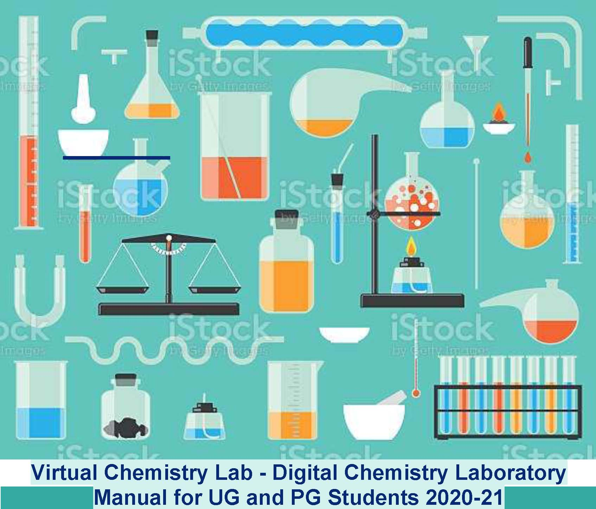
Department of Chemistry Union Christian College, Aluva

- Digital Chemistry Laboratory Manual
Department of Chemistry, Union Christian College, Aluva
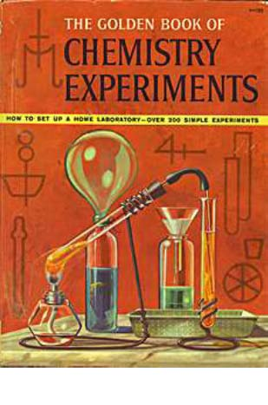
“Exciting live chemistry demonstrations with required instructions and science behind will be updated on an LMS platform or department website”
Vision to become a great experimental Chemist, is accompanied with the understanding of both theory and technique associated with each experiment. The "Digital Chemistry Laboratory Manual" is conceived as a series of videos designed to help students familiarize with our chemistry laboratory class. Each video provides a detailed demonstration of a common laboratory technique, as well as helpful tips and information. These videos are meant to supplement, and not replace, the lab manual and assigned reading. Students will benefit from watching the elaborate videos if they have already read the appropriate background information. Special modules for core and complementary streams of Undergraduate and Postgraduate students is envisaged in a systematic manner and can be utilized for years to come.
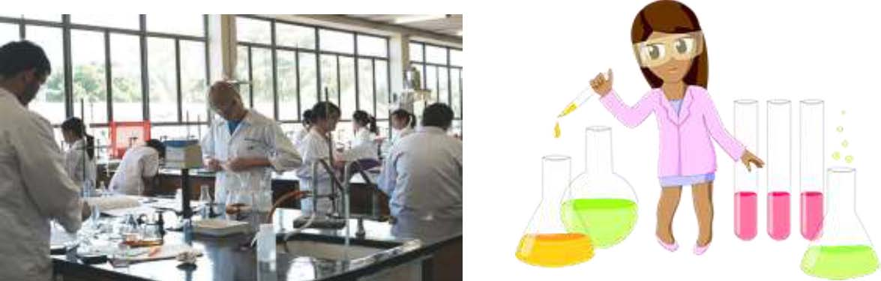
2

5. Major Research Project Proposals
As a part of centenary year activity, we, the faculty would like to submit a major research proposal to the funding agency, Department of Science & Technology (DST) - Science and Engineering Research Board (SERB), Govt. of India for getting financial support.
We require financial support to strengthen our research and as a part of it we humbly request for some basic infrastructure facilities (space for well furnished research room, good internet connectivity, computer facility etc) from our college.
DST-SERB, Govt. of India is implementing a Technology Systems Development Programme (TSDP). The Programme supports activities aimed at developing and integrating technologies to evolve technology systems both in the advanced/emerging areas and in the traditional sectors/areas. Under the Programme, feasibility of fresh ideas/ concepts is assessed for their potential conversion into useful technology/product. A brief description of the major research proposal from our department is given below.
Title of the project: “Development of advanced materials for energy storage applications”
In the current scenario, advancement of sustainable energy resources and the associated technologies plays high priority to reduce the impact of fossil fuels on our ecosystem. The area of renewable energy harvesting, its storage and conversion, by cost effective and green approaches is one of the frontier areas of global research activity. Although tremendous advances have been made in renewable, pollution free and clean power generation, its transport, storage and conversion, more efficient, flexible and economically viable approaches for wide spread use have yet to be realized. Cost and long term stability are some of the prime challenges for these clean and green technologies to be made accessible to all sections of the society without stringent financial burden.
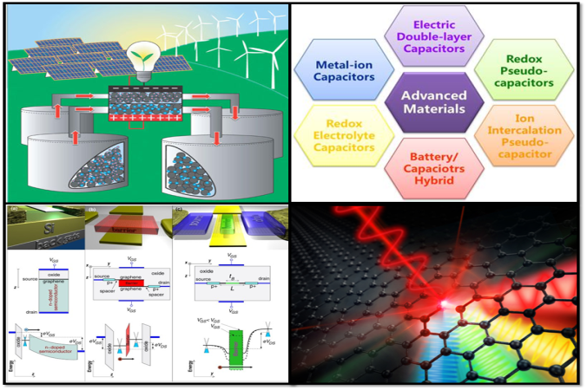
The focal themes of the project hence encompass solar power generation and fuel cell technology for energy harvesting, with special emphasis on cost effective approaches. For energy storage, the prime focus is on lithium ion secondary battery systems, supercapacitors and the recently emerging category of flexible storage devices. Large areas display devices and organic/ polymer LEDs for economically viable lighting applications which includes the main theme for energy conversion applications.
Electrochemical supercapacitors and fuel cells are all recognized as the most important electrochemical energy storage/conversion devices. Among these, ultracapacitor also known as super capacitor plays vital role in various fields of scientific research. Supercapacitors are a type of new energy saving and conversion equipment that is supposed to have the potential of high-power density, great circulation feature, rapid discharge-charge, poor self-discharging, safe working, and low cost. The significant impact of nanostructured materials with special relevance to carbon based nanomaterials of graphene and functionalized graphene and carbon nanotubes in making these technologies more economic and achieving flexibility in device design strategies is also addressed as part of the focal theme.
The project proposals will be submitted by the coming year for financial support from DST-SERB. The proposed project is multi-disciplinary, multi-institutional, industry associated mega budget project for development of technology, technique, process, product etc. including field trials, up-scaling of the developed technology.
We also like to submit two more proposals to the Kerala State Council for Science, Technology and Environment (KSCSTE) and Indian Space Research Organization (ISRO) for extending the financial support. We will be able to focus more on our research as soon as the fund is released from the agency.
- Environmental Awareness Program
Environmental Pollution
Pollution is the effect of undesirable changes in our surroundings that have harmful effects. Pollutants include solid, liquid or gaseous substances
Types of pollutants
- Degradable or non-persistent pollutants: These are rapidly broken down by natural processes. Eg: Domestic sewage, discarded vegetables etc.
- Slowly degradable or persistent pollutants: These take decades to degrade and are harmful to the environment. Eg: DDT (Pesticides) and most plastics.
- Non-degradable pollutants: These cannot be degraded by natural processes and have harmful effect on human health and environment for several decades. Eg: Toxic substances like lead or mercury and nuclear wastes.
classication of pollution
- Air Pollution
- Noise Pollution
- Water Pollution
- Thermal Pollution
- Soil Pollution
- Nuclear Pollution
- Marine Pollution
SUSTAINABLE DEVELOPMENT
Sustainable development is a development that meets the needs of the present generation, without compromising the ability of future generations to meet their own needs. The concept of sustainable development can be defined as maintenance and sustainable utilisation of the functions (goods and services) provided by natural ecosystems and biospheric processes.
Salient features of sustainable development
- It considers the equity between countries and continents, races and classes, gender and ages.
- It includes social development and economic opportunity on one hand, and the requirements of the environment on the other.
- It is a process which leads to a better quality of life while reducing the impact on the environment.
- It acknowledges the interdependence of human needs and environmental requirements.

Measures to maintain sustainable development
- Implement and maintain ethical business practices and sound systems of corporate governance.
- Integrate sustainable development consideration with in the corporate decision – making process.
- Uphold fundamental human rights and respect cultures, customs and values in dealings with employees and others who are affected by our activities.
- Implement risk management strategies based on valid data and sound science.
- Seek continual improvement of our health and safety performance.
- Seek continual improvement of our environmental performance.
- Contribute to conservation of biodiversity and integrated approaches to land use planning.
- Facilitate and encourage responsible product design, use, re – use, recycling and disposal of our products.

The Importance of Environmental Awareness
Environmental awareness is important because it has positive effects on environmental health, sustainable development and reducing global warming. Educational organisations play a huge role in this process as we can set good environmental standards for employees, students and the general public. By doing so, we build a positive public image and people will use their resources or services more.
The single most important thing that environmental awareness does is to inform people of the dangers of continuing to consume as much as we currently do. This is because people need a good understanding of the threats to our earth, to fully realize the scale of harm. Consequently, awareness is all about topics like environmental health, sustainable development and global warming.
A healthy environment leads to healthy people. As a result, organisations should be really careful about recycling and disposing of materials. We rely on our earth to supply us with clean water, breathable air and healthy food, all of which can be put in danger with sloppy throwing away of rubbish.
During the Environmental Awareness Program, we wish to conduct a series of lectures about environmental Pollution and Sustainable development, Elocution, Poster Designing, Quiz, PPT Presentation Competitions etc for the students of our college.

- CHEMIE WORLD – Webinar series 2020
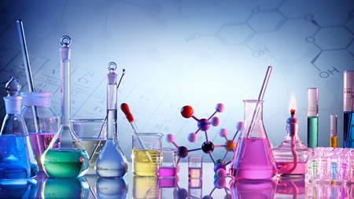
Tailor your journey, find your interest and achieve beyond what you expect

The Department of Chemistry, Union Christian College, Aluva is planning to organize a Webinar Series in different fields of Chemistry. This Webinar series definitely puts the needs and interests of students and researchers.

CHEMIE WORLD is a Webinar series in Chemistry which plays a great platform to discuss and learn about latest advancements and novel approaches in different fields of chemistry. It aims to bring together leading academic scientists, researchers and students to exchange and share their experiences and research results on all aspects of chemistry and related fields.
It also provides a premier interdisciplinary platform for researchers, practitioners and educators to present and discuss the most recent innovations, trends, and concerns as well as practical challenges encountered and solutions adopted in the fields of Chemistry. To discuss the issues and accomplishments in the field of Chemistry, Webinar Series has taken the initiation to gather the world class experts both from academic and industry in a common platform.
Objectives
- To help students and researches to develop professional skills and attitudes of scientists.
- To familiarize the students with the opportunities and requirements for a career in chemistry or a chemistry-related field.
- To introduce ideas or topics of growing importance related to chemistry which were not typically covered in General Chemistry.
- To further prepare students for the transition from their undergraduate experience to the next step in their careers as scientists.
- To encourage thought about those characteristics that contribute to the making of a good scientist and to emphasize how diversity of perspective and talents can help solve scientific problems.

Platform: Google meet, Zoom, Cisco Webex etc

Facilities Required: Reliable Internet Connection

Webinar Topics include
Green Chemistry – Cutting edge research for a greener sustainable future
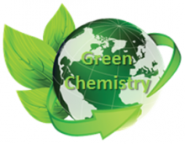
Green chemistry also known as sustainable chemistry, is the design of chemical products and processes that reduce or eliminate the use or generation of hazardous substances. Green chemistry applies across the life cycle of a chemical product, including its design, manufacture, use and ultimate disposal. It prevents pollution at the molecular level, applies innovative scientific solutions to real-world environmental problems, reduces the negative impacts of chemical products and processes on human health and the environment and designs chemical products and processes to reduce their intrinsic hazards
Cosmetic Chemistry
Cosmetics are products designed to cleanse, protect and change the appearance of external parts of our bodies. The key ingredients present in most cosmetics include water, emulsifiers, preservatives, thickeners, moisturisers, colours and fragrances. Ingredients can be naturally occurring or artificial, but any potential impact on our health depends mainly on the chemical compounds they are made of. The doses of potentially dangerous chemicals found in cosmetics are considered too small to pose a risk to human health

Forensic Chemistry (Criminalistics): Identify the Mystery
Forensic science is the application of scientific knowledge and methodology to criminal investigations and legal problems. Forensic Science is a multidisciplinary subject, it encompasses various fields of science such as chemistry, biology, physics, geology, psychology, social science, engineering, etc.
Nanoscience and Nanotechnology: Thinking big Working small
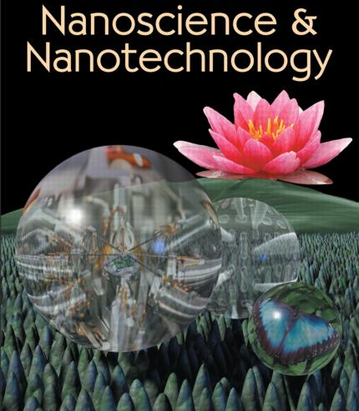
Nanoscience and nanotechnology are the study and application of extremely small things and can be used across all the other science fields, such as chemistry, biology, physics, materials science, and engineering. Today's scientists and engineers are finding a wide variety of ways to deliberately make materials at the nano scale to take advantage of their enhanced properties such as higher strength, lighter weight, increased control of light spectrum, and greater chemical reactivity than their larger-scale counterparts.
Biochemistry: Tool for sustainable development
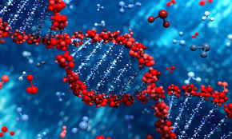
Biochemistry can be stated as the science concerned with the chemical basis of life. The cell is the structural unit of living organisms. In this way, biochemistry can also be defined as the science concerned with the chemical constituents of living cells and with the reactions and processes they experience. Biochemistry incorporates huge territories of cell biology, of molecular biology, and of molecular genetics. The significant target of biochemistry is the complete understanding, at the molecular level, of all of the chemical processes related with living cells. To accomplish this target, biochemists have tried to disengage the various particles found in the cells, determine their structures, and examine how they work.
Nutrition and Food Chemistry: Right Nutrition for Healthy Living
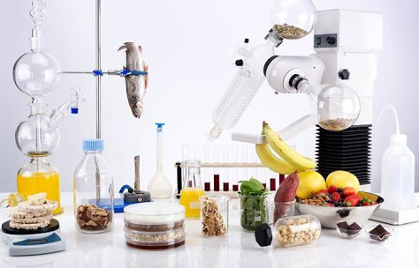

Food science is used to study physical, biological, and chemical makeup of food, and the concepts underlying food processing. Food technology is one of the applications of food science and deals with the preservation, processing, packaging, distribution, selection and use of safe food. Nutrition and food chemistry is used to study the chemical processes and interactions of all biological and non-biological components of foods. It covers the basic composition, structure and properties of foods and chemistry changes occurring during processing and utilization. It also focuses on the chemistry of water, carbohydrates, proteins, lipids, vitamins, minerals and enzymes.

Photochemistry
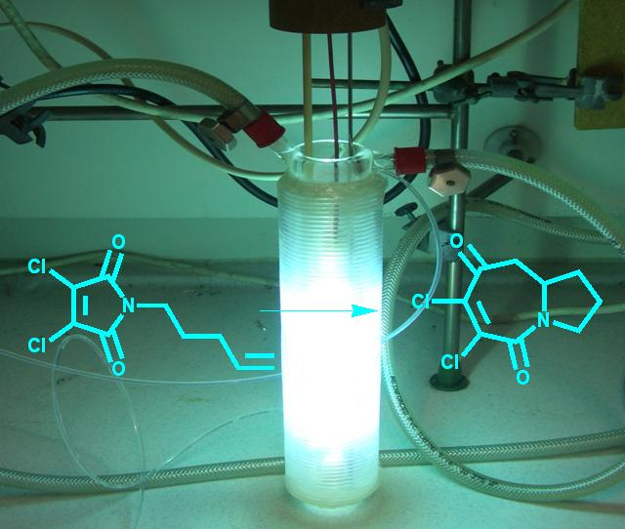
Photochemistry, a branch of chemistry, deals with the chemical processes which are caused by the absorption of light energy. Photochemical reactions are utilized in synthetic chemistry to produce various organic molecules. In addition, many common processes are photochemical in nature and have important applications. This field of science is of gigantic vitality as it is the beginning of photosynthesis, vision, and the game-plan of vitamin D with sunlight.
Supra molecular Chemistry: Multi-molecular systems
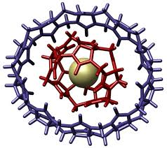
This area of science spotlights on the frameworks made up of a discrete number of gathered atomic subunits or segments. The powers in charge of the spatial association may shift from feeble (intermolecular powers, electrostatic or hydrogen holding) to solid (covalent holding), gave that the level of electronic coupling between the atomic part stays little as for important vitality parameters of the segment. Supra molecular science analyzes the weaker and reversible non-covalent collaborations between particles.
Polymer Technology
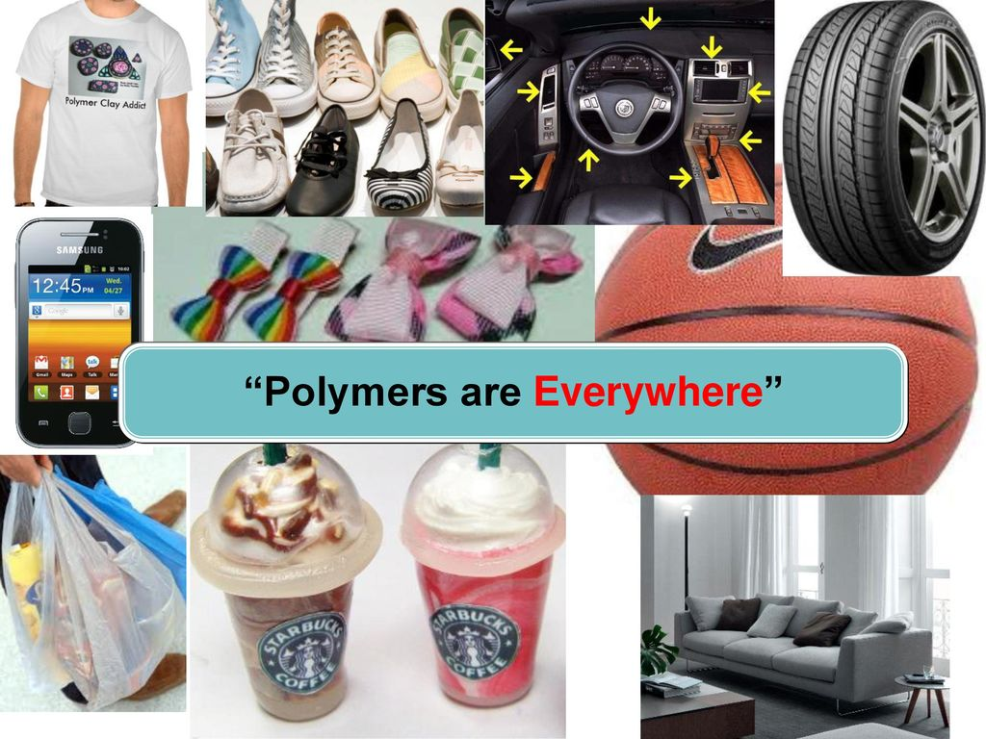
Polymer chemistry is a sub-discipline of chemistry that focuses on the chemical synthesis, structure, chemical and physical properties of polymers and macromolecules. Polymer chemists study large, complex molecules (polymers) that are built up from many smaller (sometimes repeating) units. They study how the smaller building blocks (monomers) combine, and create useful materials with specific characteristics by manipulating the molecular structure of the monomers/polymers used, the composition of the monomer/polymer combinations, and applying chemical and processing techniques that can, to a large extent, affect the properties of the final product. Materials that are regularly delegated polymers include: plastics, paints, elastic, froths, glues, sealants, varnishes and some more.

Advanced Medicinal chemistry: Drug Design and Development
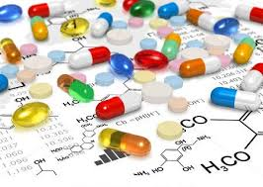
Medicinal chemistry and pharmaceutical chemistry are disciplines at the crossing point of chemistry, particularly synthetic organic chemistry, and pharmacology and different other biological specialties, where they are associated with design, chemical synthesis and advancement for market of pharmaceutical specialists, or bio-active molecules or drugs.
Action Plan:
Eminent and distinguished scientists in the particular field of interest will be identified by the Faculties of Department of Chemistry, Union Christian College and will be invited through official channels. We are planning to conduct the Webinars on Saturdays or Sundays, so that the event can be accessible to all students, researchers, scientists etc without affecting their academics. Even though the event date is prefixed as Saturdays or Sundays, depending upon the convenience of the speaker, the department is willing to negotiate as and when the selected topic is closely associated with the curriculum or a recent discovery has happened in that particular area, which is having greater academic interest.

8. Rebuilding Our Campus at UCC
1. INTRODUCTION
Plastic has become the most common material since the beginning of the 20th century and modern life is unthinkable without it. The quantum of plastic waste is ever increasing due to increase in population, developmental activities, changes in life style, and socio-economic conditions. Unfortunately, what makes it so useful, such as its durability, light weight and low cost, also makes it problematic when it comes to its end of life phase. There has been a constant rise in the consumption of plastics in India over the years and the figure below shows a study by Times of India in 2019 depicting the 10 major cities contributing to plastic waste in India. Kochi seems out of the list which is a good sign and thanks to the Kerala Government for putting a ban on single use plastics. But, that is not all. What do we do with the already accumulated ones in our home, office, industries, and so on? Where do we start?
Figure 1: Result of the study conducted by Times of India in 2019 on the plastic waste generated in India.
Plastic waste can be managed by several ways like re-use, re-cycle or by degradation. Most of the developed countries re-cycle their plastic waste. But the recycled plastics are more harmful to the environment than the virgin products due to mixing of colour, additives, stabilizers, flame retardants etc. Hence, we need a process to manage our plastic waste with less pollution effect. Unlike developed counties, developing country has immense opportunity to re-use plastic waste for constructing buildings, roads etc. During road construction plastic wastes can be used as a binder for the bituminous mixture because it provides more strength and durability to the road. Very recently different kind of plastic bricks became popular such as eco-bricks, sand-plastic composite etc.
2. OBJECTIVES
Recycling is processing used materials (waste) into new products to prevent waste of potentially useful materials. Like us in developing countries the increase in the popularity of using environmental friendly, low cost and lightweight construction materials in building industry has brought about the need to investigate how this can be achieved by benefiting to the environment as well as maintaining the material requirements affirmed in the standards. To protect the environment as well as to take advantage of plastic, recycling procedure is used. Most importantly plastic bricks could protect Indian homes from monsoon. Also this low cost or zero cost bricks can be made easily by 800 million people of India that lies below the poverty line to build their low cost house. The use of waste plastic bottles for the production of bricks is an optimal method to solve the problem of storing waste materials and to optimize the cost for the production of building materials (Figure 2).
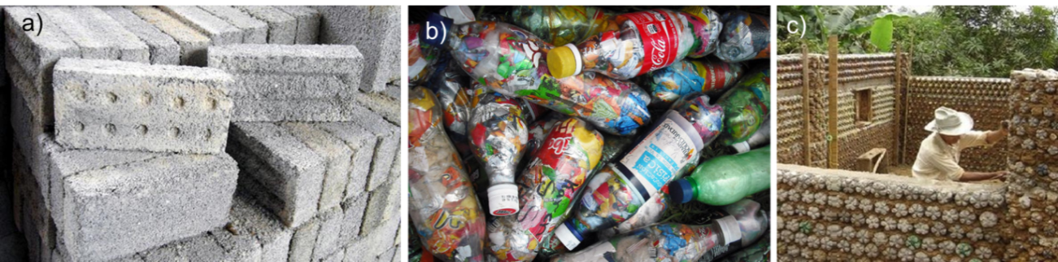
Figure 2. a) Plastic-sand composite brick; b) Eco-brick by filling plastics into plastic bottles; c) low cost housing by using eco-bricks.
In this proposal, plastic waste will be used as a binder for sand to produce sand bricks. These bricks may be used to make modular furniture, garden spaces and full scale buildings such as schools and houses. The bricks can also be tested to study the compressive strength, water absorption and efflorescence. In the recent past research, the replacement and addition have be done with the direct inclusion of polyethylene or plastic fibre, polyethylene terephthalate (PET) bottles in shredded form, chemically treated polyethylene fibre, PET in aggregate form by replacing natural coarse aggregate.
The developed composite bricks may be used for the college beautification, construction of compound walls, as pavement blocks, and many more.
3. WORK PLAN
Plastics have a unique binding property due to the interdigitation of long polymeric chains. Hence, plastic may be used instead of cement for making bricks which can have similar strength and durability with some extra advantages like high acid and alkaline stability that makes it useful for low-cost housing. The collected plastic waste (including plastic carry bags, cans, bottles, etc) may be cut into fine pieces using a shredder which may then be mixed with adequate amount of beach sand pre-heated in a furnace at 200 ºC. The mixture is kept for a fixed time at that temperature and then transferred to a suitable mould to get the brick of desired length, breadth and shape. The bricks may also be painted for appealing looks.
4. FACILITIES REQUIRED
- Shredder
- Furnace
- Mould
This project proposal is one with minimum requirements and can be met with greatest ease if sufficient funding is released. The time frame proposed for the trial is 2 months once the requirements are met.
5. REFERENCES
- https://www.thenewsminute.com/article/building-waste-these-young-kerala-engineers-recycle-plastic-waste-bricks-57550
- https://edition.cnn.com/2019/11/25/asia/plastiqube-brick-india-scn-intl-c2e/index.html
- https://www.expertskiphire.co.uk/plastic-bricks
- https://madhavuniversity.edu.in/manufacturing-and-testing-of-plastic-sand-bricks.html

- DBT Star sponsored Centenary lecture series
Like the vast tradition and legacy of Union Christian College, Indian chemists with rich tradition in the area of chemical sciences who are currently practicing it will be invited to deliver their discoveries to the enthusiastic student’s community of UCC. This will give an opportunity for students and faculties of nearby educational institutions to listen and interact with the eminent speakers. The topics of this lecture series covers the strategies of conventional approaches coupled with technological advancements, leading to innovations in the area of chemical sciences. The theme of the lecture series is “Energy, Environment and sustainability”
Intended Audience: Graduate and post graduate students of science stream, faculties of any science discipline
Duration of the program: 90 minutes (Speaker intro-10 mnts, talk-55 mnts, interaction-25 mnts)
Venue: Seminar Hall, Union Christian College, Aluva
Action plan:-Renowned scientists who preach and practice green chemistry protocol for the sustainable development of methods and materials will be identified by the academic committee of chemistry department, union Christian college and will be invited through official channels. This process is planned to happen at least two months prior to the actual day of the talk, so that the event can be popularised within and outside the chemistry fraternity. The sponsorship under the DBT Star college scheme will give us a better visibility while inviting the speaker. Even though the event date is prefixed as second Friday of every month, depending upon the convenience of the speaker, the department is willing to negotiate as and when the selected topic is closely associated with the curriculum or a recent discovery has happened in that particular area, which is having greater academic interest.
Funding: The lecture series is planned to utilise funds from the DBT Star sponsorship

